1. Create the database (CustomerInfo) and (Contacts) table on SQL Server:

example database:

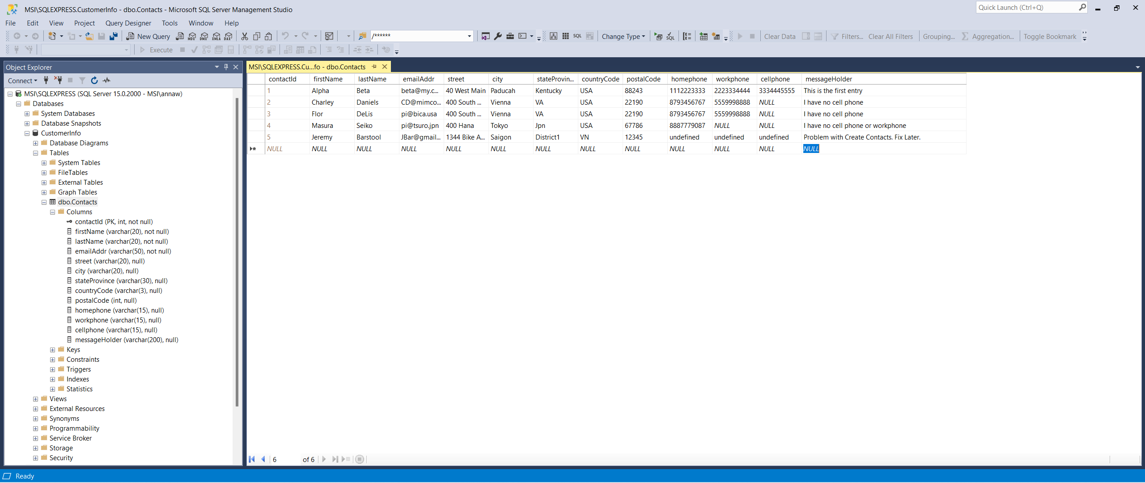

Example SQL Queries

create table Contacts (

contactId Int Not Null Identity Primary Key,

firstName varchar(20),

lastName varchar(20),

emailAddr varchar(50),

street varchar(20),

city varchar(30),

stateProvince varchar(30),

countryCode varchar(3),

postalCode int,

homePhone varchar(15),,

workPhone varchar(15),

cellPhone varchar(15),,

message_holder varchar(200)

)

SQL Query to place ‘test’ data into the Contacts table

INSERT INTO Contacts( firstName,lastName, emailAddr,street,city,stateProvince, countryCode,

postalCode, homePhone,workPhone,cellPhone, ,message_holder) VALUES

('James', 'Kilgore', 'JKil@gmail.com','60 West 6th','Peru', IN, 'USA', '12345', '5553434', '222343456', '1234567890', 'Everything is Here.');

Write an SQL-Server **stored procedure** to be executed in the routing

/****** Stored Procedure ******/

CREATE PROCEDURE [dbo].InsertOrUpdateContact

@contactId int = 0,

@firstName varchar(20),

@lastName varchar(20),

@emailAddr varchar(50),

@street varchar(20),

@city varchar(20),

@stateProvince varchar(30),

@countryCode varchar(3),

@postalCode int,

@homephone varchar(15),

@workphone varchar(15),

@cellphone varchar(15),

@messageHolder varchar(200)

as

BEGIN

if (@contactId = 0) INSERT INTO [dbo].[Contacts]

([firstName],[lastName], [emailAddr], [street], [city], [stateProvince],

[countryCode],[postalCode], [homephone], [workphone],[cellphone],[messageHolder])

VALUES

(@firstName,@lastName, @emailAddr, @street, @city, @stateProvince,

@countryCode,@postalCode, @homephone, @workphone,@cellphone,@messageHolder)

else UPDATE [Contacts]set

[firstName]=@firstName, [lastName]=@lastName, [emailAddr]=@emailAddr, [street] = @street,

[city]= @city, [stateProvince]=@stateProvince,[countryCode]= @countryCode, [postalCode]= @postalCode,

[homephone]= @homephone,[workphone]= @workphone,[cellphone]= @cellphone,[messageHolder] = @messageHolder

where [contactId]= @contactId

END

Results appear as follows

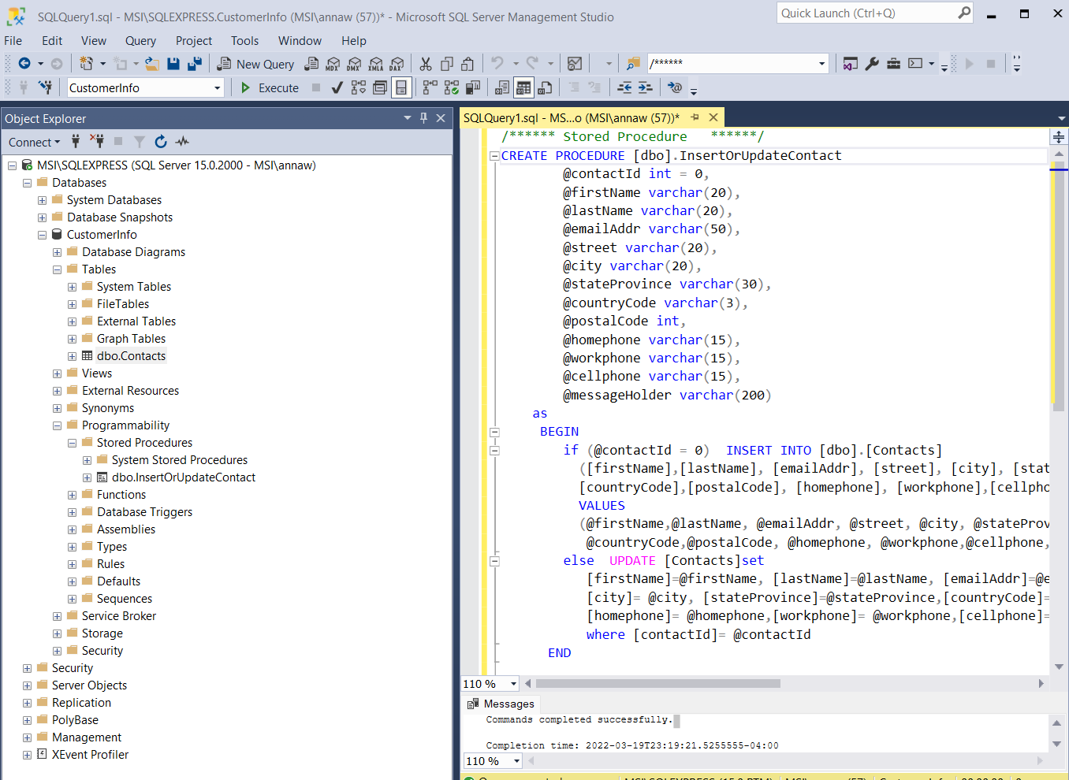**connectivity.**

************************************************************---

We connect to the SQL Server and create a new SQL Authenication

In the example, we Change the *User Name* to Foui

Change the *Password* Foui

Server Here is MSI\SQLEXPRESS

SQL Server is on MSI (needed to connect)

Instance Name is SQLEXPRESS

Database Name is CustomerInfo

Table Name is dbo.Contacts

Connect to the database using **windows authentication**.

Right Click on Security. then New Login

* Choose “SQL Server Authentication”
* Enter UserName, Password
* Uncheck **all** boxes, then click OK  
    
  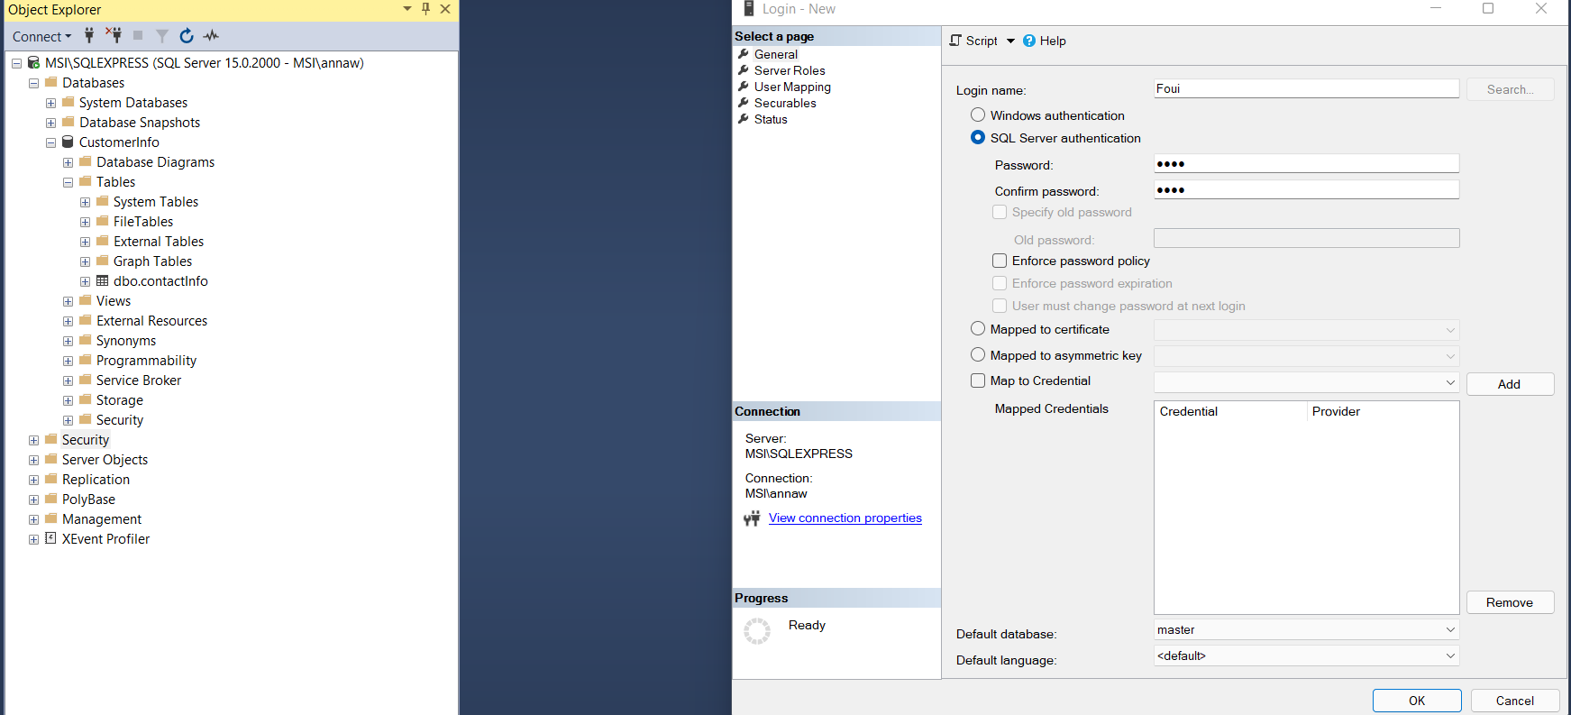
* Security Properties for the new user:   
   in Security, select new login name( Fuoi) properties

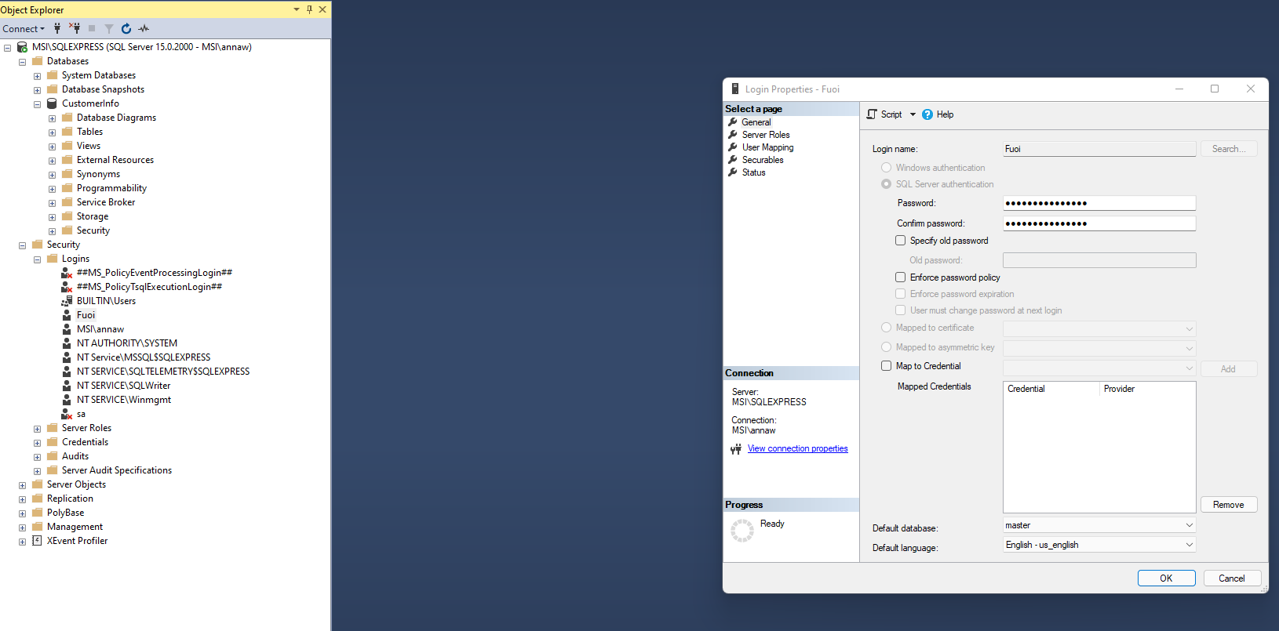

* Now to change database owner (dbowner)
* Select User Mapping, Select the database (Customer Info)
* select dbowner, public to get write/read permissions to database  
  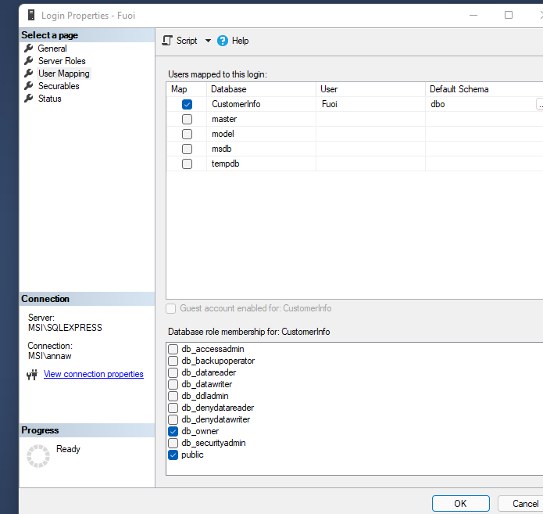
* In this section we will use the computer management tool to enable the *IP address* and set the **port** to 1433  
    
  * Enter Window R or (my keyboard ‘start/alt op R’) when the window comes up enter  
   compmgmnt.msc (Microsoft Computer Management tool)
* Configure SQL-Server to allow alternate owners and allow external interface
* Click on “windows R” (start R) then type ‘compmgmnt.msc’ to
* 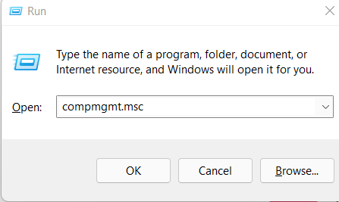
* Select “Services and Applications” then “SQL Server Configuration Manager” then
* “SQL Server Network Configuration” and select the ServerName then
* Enable TCP/IP and select “OK”
* 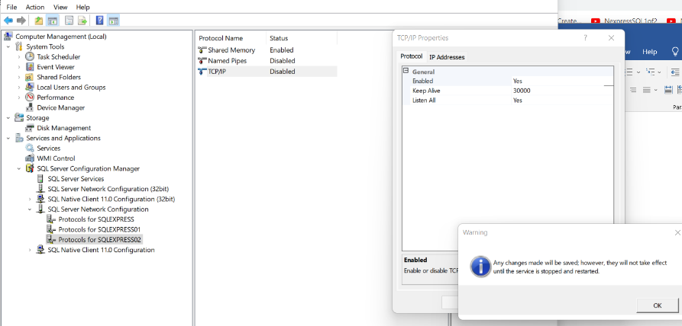
* Additionally configure the enables tcp/ip “ properties” ip-all to run on port 1433
* 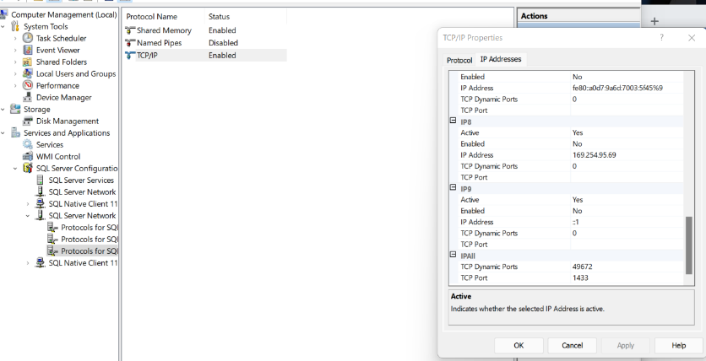

How to Restart the server: After making the above changes to TCP/IP, you must Restart the Server

In the windows Search Bar … enter services

* Scroll down to find the SQL-Server, **right click** on it, select “restart”  
    
  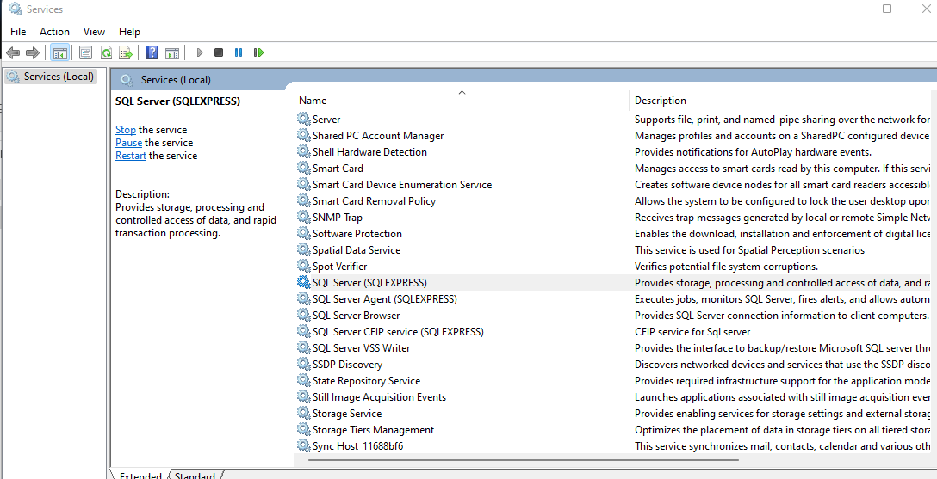

The database is now ready to create an application that can access the database

Bring up SQL Server Management screen, record the server name: MSI\MSSQLSERVER01

The server instance (here) is MSSQLSERVER01

Change the Authentication from WINDOWS AUTHENTICATION to SQL SERVER AUTHENTICATION

Change login name and password. Here I’ll use “Foo” and “Foo” to make it memorable to me. Your

Server application will later use that information

Open SQL Server, press “control R” or “Windows R”, run ‘compmgmt.msc’